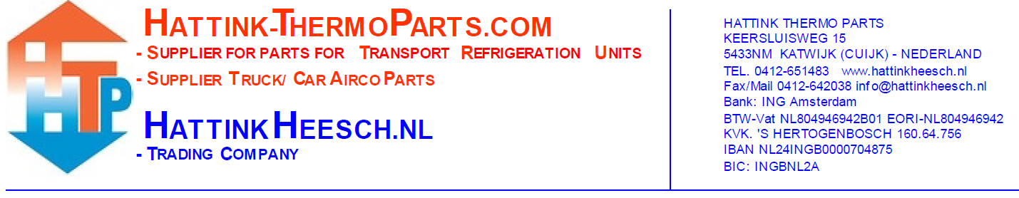
To: Hattink Thermo Parts
Keersluisweg 15
5433NM Katwijk (Cuijk)
The Netherlands

Return to Hattink Thermo Parts
Return number:
Your data:
Company name:
Customer number:
Your bank details:
Bank/Giro number:
Accountholder:
Number | Articlenumber | Receiptnumber | Reason of return | Comments

There must be given an approval before you send the items back! Without a return number no return!
You can find information about returns on our website among ‘Customer service’.
(www.hattink-thermoparts.com/customerservice)

